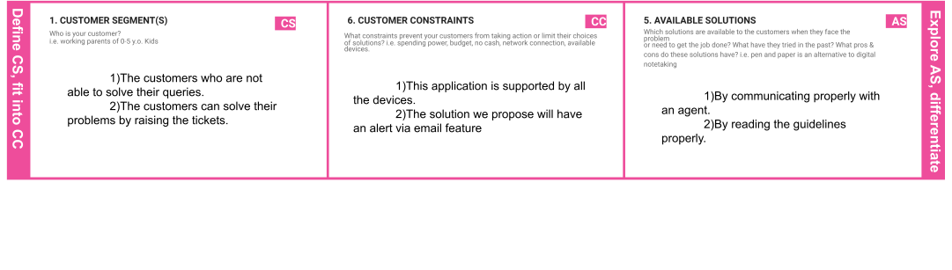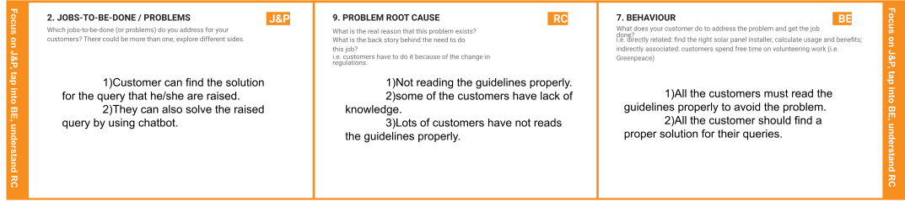

**Project title:** Customer care registry **project design phase-I:** solution fit template **Team ID:** PNT2022TMID37726

|  |  |  |  |  |
| --- | --- | --- | --- | --- |
|  | **4. EMOTIONS: BEFORE / AFTER EM**  How do customers feel when they face a problem or a job and afterwards?  i.e. lost, insecure > confident, in control - use it in your communication strategy & design.  The customer can get help from our agents we are assigned and they feel very satisfied with our services. | Our solution is to design a helpdesk that  is helpful for customer to solve their queries that they have raised. | **8.2 OFFLINE**  What kind of actions do customers take offline? Extract offline channels from #7 and use them for customer development.  They can get better solutions for the queries they raised. |  |

|  |  |  |  |  |
| --- | --- | --- | --- | --- |
|  | **3. TRIGGERS TR**  What triggers customers to act? i.e. seeing their neighbour installing solar panels, reading about a more efficient solution in the news.  The customer must know how to solve the problem. | **10. YOUR SOLUTION SL**  If you are working on an existing business, write down your current solution first, fill in the canvas, and check how much it fits reality.  If you are working on a new business proposition, then keep it blank until you fill in the canvas and come up with a solution that fits within customer limitations, solves a problem and matches customer behaviour. | **8. CHANNELS of BEHAVIOUR CH**   * 1. **ONLINE**   What kind of actions do customers take online? Extract online channels from #7  All the data that are provided by the customers are very safe in cloud storage. |  |